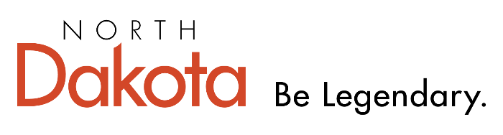

**Rural Catalyst Grant 25-27 Biennium**

**Narrative Description Application Questions:** Please briefly address the following (365 Form). Point total is 140. Each question should be addressed within each block of the application; there is a 550 word maximum but, if necessary, the applicant may upload *additional* narrative to provide further details.

1. **Organization Information (10 points)**
   1. Contact information of individual filling out form
   2. Name of the Official applicant / partner organizations (ie city, county, JDA, tribal council, regional council)
   3. Clear, concise and accurate project description
   4. Application is accurate and the applicant’s original work and authentic voice. It represents critical thinking and is not fully AI-generated.
2. **Economic Development impact (20 points)**
   1. Please describe how your project would create or preserve jobs
   2. Please describe hour your project supports entrepreneurship and/or new business activity in your community?
3. **Community Vitality Impact and Quality of Life Improvement (40 points)**
   1. Please list the rural community(s) that will benefit from this project
   2. How will this project address your community’s vitality in terms of promoting livability, safety, recreational opportunities or cultural enrichment?
   3. Please address how this project will serve a critical need in your community: education, health, wellness, improvement to essential services, housing, transportation, for the purpose of reserving or reopening a rural grocery store, or other?
4. **Local Commitment, Project Budget and Timeline (20 points)**
   1. Please provide a detailed project budget that includes the following (*be as specific as possible to help us understand how funds will be allocated and financially supported*):
      1. Total cost of the project
      2. Amount you are requesting through this grant
      3. A breakdown of matching funds, including sources and amounts (cash and in-kind donations)
   2. Please provide a detailed project timeline, showing when, if funded, you anticipate the project would commence and be completed. Please include interim and major milestones in the planning process.
   3. Please provide objectives, and anticipated outcomes of your project, after completion.
5. **Project Sustainability (20 points)**
   1. How likely is this project able to sustain itself after the grant ends? Please explain.
6. **Innovation and/or Replicability (10 points)**
   1. How does your project introduce innovative solutions to address rural challenges, and in what ways can the model be replicated or scaled in other communities?
7. **Supplemental Materials (20 points):**
8. If applicable, include any pictures you feel the board may find helpful.
9. Most recent community plan(s)
   1. Please submit or link to a copy of your community’s most recent plan(s) that may address the need for this project.
10. Letter of support from local organizations and/or political entities
    1. Please provide a letter of support, indicating participation in the process and specifically referring to this grant application, from any of the following partners
       1. Local school district
       2. Local parks and recreation district (or similar)
       3. JDA, chamber or other economic and/or community development organizations
       4. City and/or County Commission/Council
       5. Regional council

**Application Deadline:** Please ensure that you address each of the questions above in your application in the respective text boxes within your online application, the maximum word count is 550 words per box*. If you need additional narrative, please upload additional documents to the supplemental portion of the application.* All application materials must be received at the Department of Commerce office no later than ***5:00 pm CDT Wednesday, January 7, 2026***. Applications received after the deadline will not be considered by the review committee. All applications must be completed online through the Department of Commerce D365 online portal. No emailed or mailed applications will be accepted.

*For more information contact Nicolette Blumler, at* [*nblumler@nd.gov*](mailto:nblumler@nd.gov), 701-328-7924.